Baby Sign Language
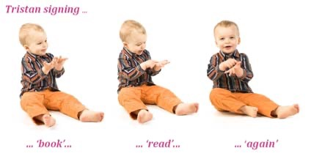
What is Baby Sign
Why use baby sign with infants and toddlers? Studies have shown:
History of Baby Sign
When is the best time to start Baby Sign? Answers to many questions people have! How do I start?
Signs To Start With: Songs To Begin With:
Make these into flash cards and work with your families

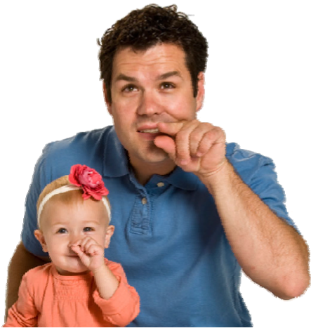

What is Baby Sign?
- Baby sign is using non‐verbal hand and body gesturing to communicate with an infant or toddler.
- Most signs are adapted or used straight from ASL (American Sign Language)
- You can create your own signs and most children will form them their own way until they can manipulate their hands more accurately.
- I use ASL as I sign fluently and work with deaf children and adults.
Why use baby sign with infants and toddlers?
- Before a child can use the spoken word, they use non‐ verbal forms of communication and gesturing.
- It can alleviate communication frustration between the parent and child. This may also decrease tantrums in a child.
- It is another great form of bonding.
- Baby sign can help a child talk sooner.
- A child can use the signs to give them a sense of accomplishment.
- This is a great building block on literacy skills.
- Boost’s brain development.
- Can take away guess work and calm a child faster.
Studies have shown:
Michigan State University Study Dr. Linda P Acredolo and Dr. Susan W. Goodwyn
* +12 IQ point advantage
** Larger speaking vocabulary
*** Earlier reading and larger reading vocabulary
**** Better Grades in school
American Academy of Pediatrics
- Emotional benefits reported
** Babies have fewer moments of stress
***Parents feel a closer bond and more tuned into their child
****Parents feel better about themselves
- Research on baby sign language has found that teaching baby signs improved cognitive and emotional development. Far from slowing down speech, baby sign language actually increases the rate of verbal development and at the same time increases the parent/child bond.
- The most significant research was an NIH (National Institutes of Health) ‐funded study comparing two groups of 11‐month‐old babies. One group was taught baby sign language. The second group was given verbal training. Surprisingly, the signing groups were more advanced talkers than the group given verbal training. The lead of the signing group continued to grow, with the signers exhibiting verbal skills three months ahead of the non‐signers at two years old. Their lead seemed to shrink a little after two years old, but even at three years old, the signers were still ahead1.
• The authors of the NIH study followed up with the children at eight years old. Surprisingly, there was still a difference. Signers showed IQ’s 12 points higher than the non‐signers, even though they had long since stopped signing. This put the signers in the top 25% of eight-year old’s, compared to the non‐signers, who were close to average.
• Results like these have led to research on how signing could be used to improve early infant education. This research has turned up a whole host of benefits to signing. Some of these benefits include making mothers feel better about themselves and more “tuned in” to their baby, reducing baby distress and improving communication between parent and child3.
• Now keep in mind that these studies have all been relatively small – the NIH‐funded study, for example, had only 100 babies. However, these early results look very promising. These results, combined with all the anecdotal reports from signing parents, gives a lot of reason to be very optimistic about the results from future baby sign language research. http://www.babysignlanguage.com/basics/research/
When is the best time to start Baby Sign?
- You can start right away using one sign as you are doing different activities with you baby.
- They will be able to start signing back around 6months at the earliest. That is when you can start showing them how to make the signs with their hands as you do yours.
- When you start to manipulate their hands, only start with 3 to 4 signs usually “more”, “drink”, “eat”, and “all done”.
- Always use these signs while you are verbalizing the event. Also teach the child’s caregivers too.
Answers to many questions people have! 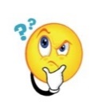
- It will not interfere with a baby’s speech development.
- It will boost a child’s communication. A child will usually start with one or two signs.
- Yes, parents and caregivers need to be patient and use the signs always.
- Pointing is part of baby sign.
- Shaking your head yes and no is a form of baby sign.
- It is never too late to start baby sign.
- Make sure you have your child’s attention when signing.
- Hold an object and sign it at the same time while vocalizing also.
- Praise your child always.
- Give them time, it won’t happen overnight.

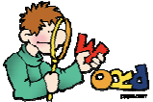
How do I start?
- With signs for everyday activities. Eat, more, all done, diaper, Drink, Mom, Dad, Book, sleep, love.
- These you start when they are born by signing and verbalizing you will be ready for then between 6 and 8 months to show them how to manipulate their hands to form the signs.
- Only start with the first 4 when showing them. Use them when you are doing those activities.
- After they start making the signs or gestures on their own, praise them, and add 1 or 2 as the child is able.
- Use kids songs as you would “So Big” or “Touch down”. “Itsy Bitsy Spider”, and “Twinkle Little Star”!
- Don’t try it when eighter of you are upset or tired out.
Signs To Start With:
- Eat
- All Done
- Drink
- More
- Diaper
- Mom
- Grandma
- Grandpa
- Help
- Dad
- Thank‐you
- Dog
- Cat
- Mine
- Tooth Brush
- Careful
- Banana
- Cereal
- Play

Songs To Begin With:
• Twinkle, Twinkle
• The Wheels on the Bus • Itsy Bitsy Spider
• 5 Little Monkeys
• Row Your Boat
• Old MacDonald
Baby Signing Songs on You Tube
- Practice to music
- https://www.youtube.com/watch?v=HtjmKHEvRb8
- Old Mac Donald
- https://www.youtube.com/watch?v=nUoipFFCEm0
- Twinkle Little Star
- https://www.youtube.com/watch?v=hl1j9797Z38
- Baby signing time
- https://www.youtube.com/watch?v=IzEim3aW254
- https://www.youtube.com/watch?v=0uK1YiHNFtU
- Eensy Weensy Spider
- https://www.youtube.com/watch?v=dB8TV1hcKuk
- Row Your Boat
- https://www.youtube.com/watch?v=NIeLL53UsRw
- https://www.youtube.com/watch?v=VhdOVQJ4Mes
- Wheels on the Bus
- https://www.youtube.com/watch?v=HzQcOYW3wRw
Just music with words to practice
- Twinkle https://www.youtube.com/watch?v=yCjJyiqpAuU
- Old MacDonald https://www.youtube.com/watch?v=qxoXvn2l2gA
- Row Your Boat https://www.youtube.com/watch?v=7otAJa3jui8
- Eensy Weensy Spider https://www.youtube.com/watch?v=kktf7w15t0Y
- Wheels on the Bus https://www.youtube.com/watch?v=HP‐
MbfHFUqs&t=2430s
• Have fun with the children. They love to play so make it all about play. Use often and play always with or without signing. Tons more so search the web and have fun!
